INTERNSHIP PROJECT REPORT
Data Analytics Internship
Project Title:
HR Attrition Analysis
Intern Name: Amey Kishor Sawatkar
Company Name: SkillInfyTech IT Solutions Pvt. Ltd.
Internship Domain: Data Analytics

Introduction
Employee attrition is one of the most significant challenges faced by organizations today, directly influencing productivity, operational costs, and long-term business stability. Understanding why employees leave an organization, and identifying the patterns behind such attrition, enables HR departments to make informed, data-driven decisions rather than relying on assumptions. This project was undertaken during the Data Analytics internship at SkillInfyTech IT Solutions Pvt. Ltd. with the aim of analyzing an HR employee attrition dataset to uncover meaningful workforce trends, demographic patterns, and retention-related insights.
The project involved working with real-world style HR data through the complete analytics pipeline — from data cleaning and preparation, to database management using SQL, and finally to the development of an interactive business intelligence dashboard using Power BI. The intent was to simulate how a data analytics professional would approach an HR analytics problem in an actual organizational setting, using industry-relevant tools and techniques.

Objective of the Project
The core objective of this project was to analyze employee attrition patterns using Python, MySQL, SQL, and Power BI, and to translate the cleaned and structured data into clear, actionable business insights. The project aimed to identify key factors contributing to attrition, understand workforce demographics, and present these findings through an interactive and easy-to-interpret dashboard that could support HR decision-making processes.

Problem Statement, Objectives & Scope

Problem Statement
Organizations across industries face a recurring challenge in retaining talent, and employee attrition often occurs without a clear understanding of its underlying causes. Without proper analysis, HR teams may struggle to identify which departments, job roles, or employee segments are most affected by attrition, and which factors — such as income levels, overtime, work-life balance, or demographic characteristics — are contributing most significantly to employees leaving the organization. This project addresses the need for a structured, data-driven approach to analyzing HR attrition data so that patterns can be identified clearly and used to support proactive retention strategies.

Main Objectives
- To clean, preprocess, and structure raw HR attrition data for analysis.
- To store and query the processed data efficiently using a MySQL database.
- To extract meaningful workforce and attrition insights using SQL queries.
- To design an interactive Power BI dashboard that visually communicates key HR metrics.
- To identify the primary factors influencing employee attrition across departments and job roles.
- To present findings in a manner that supports HR decision-making and retention planning.

Scope of the Project
The scope of this project covers the end-to-end analytics workflow applied to the IBM HR Attrition Dataset, comprising 1,470 employee records across 32 cleaned columns. The project scope includes data cleaning and preprocessing in Python, database creation and query execution in MySQL, and dashboard development in Power BI. The analysis focuses on workforce demographics, attrition trends by department and job role, income-related patterns, and the impact of work-life balance and overtime on attrition. The project is limited to descriptive and diagnostic analytics based on the available dataset and does not extend into predictive modeling.

Importance of HR Analytics in Business Decision-Making
HR analytics plays a vital role in modern organizations by shifting workforce management from an intuition-based approach to a data-driven one. By analyzing attrition trends, demographic patterns, and compensation structures, organizations can identify at-risk employee segments early and design targeted retention initiatives. Data-backed HR insights help reduce recruitment and training costs associated with high turnover, improve employee satisfaction strategies, and support long-term workforce planning. This project demonstrates how analytics can convert raw HR data into a strategic asset for business decision-making.

Tools, Dataset & Methodology

Tools and Technologies Used
- Python — for data cleaning, preprocessing, and exploratory analysis
- Pandas and NumPy — for data manipulation and numerical operations
- Matplotlib and Seaborn — for exploratory data visualization
- MySQL — for database creation and structured data storage
- SQL — for querying and extracting business-oriented insights
- Power BI — for building an interactive analytical dashboard

Dataset Description
The project used the IBM HR Attrition Dataset, a widely recognized dataset in the field of human resource analytics. The dataset originally contained employee-level information related to demographics, job roles, compensation, and attrition status. After the data cleaning process, the dataset consisted of 1,470 employee records across 32 relevant columns, covering attributes such as age, department, job role, monthly income, overtime status, marital status, education field, and work-life balance, among others.

Data Cleaning Process in Python
The data cleaning phase was carried out using Python, with Pandas and NumPy forming the core of the preprocessing workflow. Unnecessary and redundant columns were identified and removed to retain only the fields relevant to attrition analysis. The dataset was checked for inconsistencies, and column formats were standardized to ensure compatibility with downstream SQL and Power BI processes. This step ensured that the final dataset used for analysis was clean, structured, and reliable.

Database Creation and SQL Analysis Process
Following the cleaning process, a dedicated MySQL database was created to store the processed HR attrition data in a structured table format. The cleaned dataset was imported into MySQL, enabling efficient querying and analysis. A total of 50 business-oriented SQL queries were executed to extract insights related to attrition rates, departmental trends, job role patterns, income distribution, and demographic breakdowns. These queries formed the analytical foundation upon which the Power BI dashboard was later built.

Power BI Dashboard Development Process
The final phase of the project involved building a three-page interactive Power BI dashboard to visually present the analytical findings. The dashboard was designed with a clear structure to guide the viewer from a high-level executive overview to detailed employee and attrition-specific insights, with visuals for each page discussed in the Dashboard Insights section that follows.
- Page 1 – Executive Dashboard: KPI cards for Total Employees, Attrition Count, Active Employees, Attrition Rate, Average Monthly Income, and Average Age, along with visuals for Attrition by Department and Attrition by Job Role.
- Page 2 – Employee Insights: Visuals covering Gender Distribution, Employees by Age Group, Marital Status Distribution, and Employees by Education Field.
- Page 3 – Attrition Analysis: Detailed visuals on Attrition by Age Group, Attrition by Overtime, Attrition by Monthly Income, and Attrition by Work-Life Balance.

Dashboard Insights & Findings

Overall Attrition Trend
Out of a total workforce of 1,470 employees, the dashboard recorded 237 employees who left the organization, with 1,233 employees remaining active, resulting in an overall attrition rate of approximately 16%. The Executive Dashboard's KPI cards — Total Employees, Attrition Count, Active Employees, and Attrition Rate — provided an immediate, high-level view of this workforce composition, alongside an average monthly income of 6.50K and an average employee age of 36.92 years.
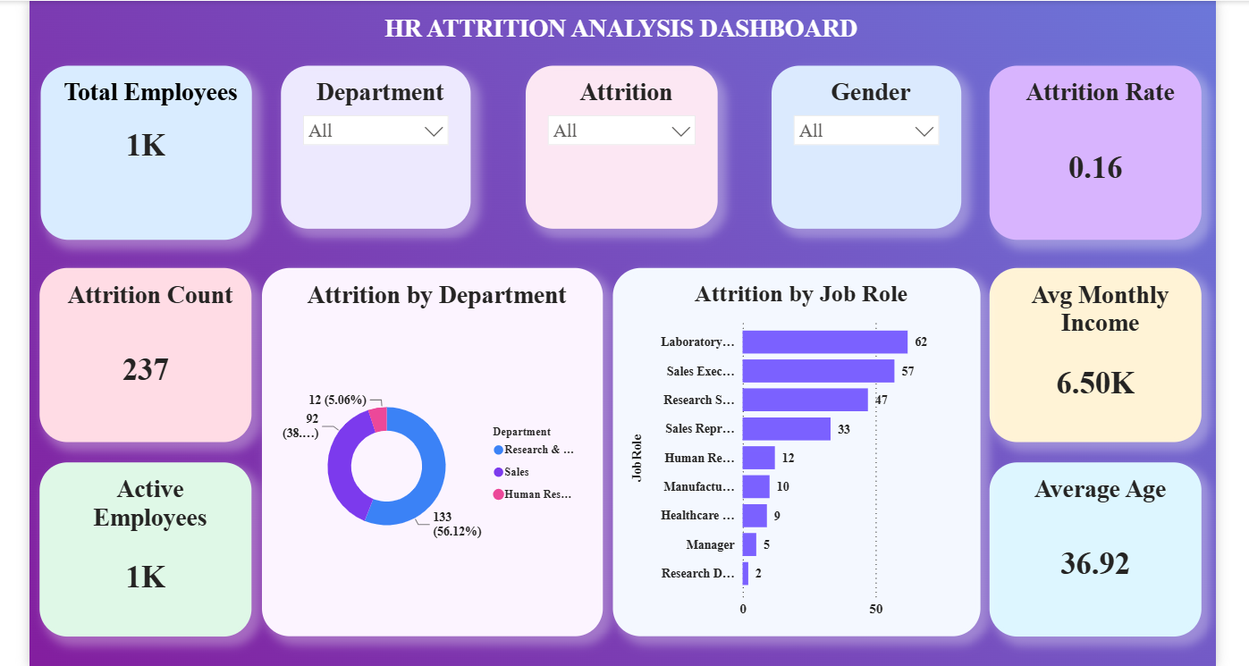
Figure 1: Executive Dashboard overview showing key attrition KPIs

Attrition by Department
Departmental analysis showed that attrition was concentrated most heavily in the Sales department, which accounted for 133 attrition cases (56.12% of total attrition), followed by Research & Development with 92 cases (38.8%), while the Human Resources department recorded only 12 cases (5.06%). This concentration indicates that department-specific factors — such as workload, targets, or role-related pressures within Sales and R&D — are contributing disproportionately to overall turnover.

Attrition by Job Role
Attrition patterns also varied significantly across job roles. The Laboratory Technician role recorded the highest attrition count at 62, followed by Sales Executive at 57 and Research Scientist at 47. Sales Representative followed with 33 cases, while roles such as Human Resources (12), Manufacturing Director (10), Healthcare Representative (9), Manager (5), and Research Director (2) showed comparatively lower attrition. This pattern suggests that entry-level and field-facing roles are more susceptible to turnover than senior or specialized positions.
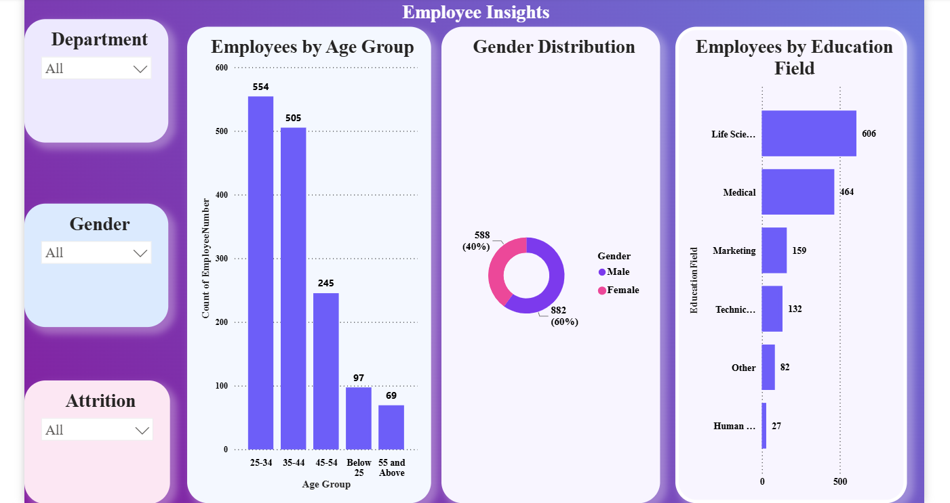
Figure 2: Employee Insights — workforce demographics by age, gender, and education field

Workforce Demographic Insights
The Employee Insights page revealed that the workforce is predominantly young, with the 25–34 age group comprising 554 employees and the 35–44 age group comprising 505 employees, together forming the majority of the organization. The 45–54 age group accounted for 245 employees, while employees below 25 and those aged 55 and above numbered 97 and 69 respectively. Gender distribution showed 882 male employees (60%) and 588 female employees (40%). Education field analysis showed that employees from a Life Sciences background formed the largest group at 606, followed by Medical at 464, with Marketing (159), Technical Degree (132), Other (82), and Human Resources (27) making up the remainder.
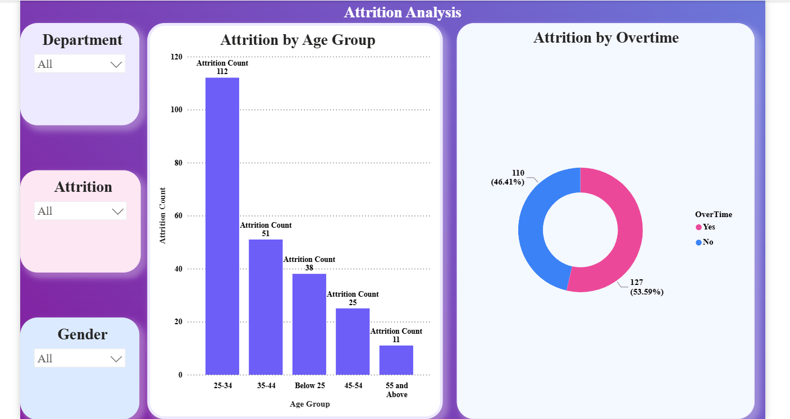
Figure 3: Attrition Analysis — attrition by age group and overtime status

Salary, Work-Life Balance, and Overtime Impact
Among the most significant findings from the Attrition Analysis page was the strong relationship between overtime and attrition: 127 attrition cases (53.59%) belonged to employees who worked overtime, compared to 110 cases (46.41%) among those who did not, confirming overtime as a meaningful driver of turnover. Age-wise, attrition was heavily concentrated in the 25–34 age group, which alone accounted for 112 attrition cases, far ahead of the 35–44 group at 51, the below-25 group at 38, the 45–54 group at 25, and the 55-and-above group at just 11. This indicates that younger employees, particularly those early in their careers, are considerably more likely to leave the organization. Additionally, patterns observed across income and work-life balance metrics reinforce that lower income brackets and poorer work-life balance ratings are associated with a higher likelihood of attrition.

Key Business Observations
- Sales and Research & Development together account for over 94% of total attrition, making them priority areas for retention efforts.
- Overtime is strongly associated with attrition, with over half of all attrition cases involving employees who worked overtime.
- Employees aged 25–34 represent the single largest attrition segment, indicating a need for stronger early-career retention strategies.
- Laboratory Technician, Sales Executive, and Research Scientist are the job roles most affected by attrition.
- Lower income brackets and weaker work-life balance ratings correspond with higher attrition likelihood.

Conclusion

Project Summary
This project successfully demonstrated a complete data analytics workflow applied to the domain of HR attrition analysis. Starting with the cleaning and preprocessing of raw employee data in Python, the project progressed through structured data storage and querying in MySQL, and culminated in the development of a comprehensive, three-page interactive Power BI dashboard. Throughout the process, 50 SQL queries were executed to extract meaningful business insights, which were then translated into clear, visual representations to support HR decision-making.

Key Business Learnings
The project reinforced the understanding that attrition is influenced by a combination of factors rather than any single cause. Overtime, age group, department, job role, income levels, and work-life balance all emerged as contributing factors to employee turnover, with the data showing that Sales and R&D employees, younger age groups, and overtime workers face disproportionately higher attrition. This reinforces the value of a multi-dimensional analytical approach when studying workforce behavior, as relying on a single metric would provide an incomplete picture of the underlying causes of attrition.

Importance of Analytics in HR Decision-Making
This project highlighted how data analytics can transform HR from a largely reactive function into a proactive, strategic one. By leveraging structured data analysis and visualization tools, organizations can identify attrition risks before they escalate, allocate retention resources more effectively, and make workforce decisions grounded in evidence rather than assumption. HR analytics, when implemented well, becomes a valuable tool for aligning workforce strategy with overall business objectives.

Final Conclusion
The HR Attrition Analysis project provided valuable, hands-on exposure to the complete lifecycle of a data analytics project — from raw data to actionable business insight. It demonstrated how Python, SQL, MySQL, and Power BI can be integrated effectively to solve a real-world business problem, and how well-structured analysis and visualization can support meaningful organizational decision-making.

Closing Statement
This project strengthened practical skills in Python-based data cleaning, MySQL database management, SQL query writing, and Power BI dashboard development. It offered a valuable opportunity to apply theoretical data analytics concepts to a practical, business-relevant scenario, and has contributed meaningfully to building a strong foundation for a career in data analytics.

